CASE-STUDY (NUMBER - 8) – SOLUTION SUBMISSION

ON

AZURE ANALYTICS

BY

NAME –SUPRIYA BHARATHA ROLL NUMBER DXCAB1211

BATCH:DXC-262-ANALYTICS-B12-AZURE COMPANY – DXC TECHNOLOGY

TRAINING UNDER – MANIPAL PRO LEARN TRAINER NAME – MR. AJAY KUMAR DATE OF SUBMISSION – 8th JUNE 2022 TOTAL NUMBER OF QUESTIONS: 10 EMPLOYEE DOMAIN - AZURE ANALYTICS

* THE QUESTIONS:

1. Explain the steps with screenshots how to create Blob storage in Azure cloud?

2. Explain the steps with screenshots how to create Virtual machine & how to connect from

(i) Local Computer - CMD method ?

(ii) Using Azure cloud Shell?

(iii) Also using Azure Bastion ?

3. Explain the steps with screenshots how to create Data factory ?

4. Explain the steps with screenshots how to copy data from source blob to destination blob ?

5. Explain the steps with screenshots how to create Virtual Network in Azure ?

6. Explain the steps with screenshots how to create azure synapse analytics ?

7. Explain the steps with screenshots how to create Azure storage account?

8. Explain the steps with screenshots how to create upload data into Azure Blobs ?

9. Explain the steps with screenshots how to create connect SQL Database in Azure ?

10. Explain the steps with screenshots how to insert data into azure SQL database ?

1. Explain the steps with screenshots how to create Blob storage in Azure cloud?

Solution:

**STEP 1:** For Blob storage account we need to search the storage account.

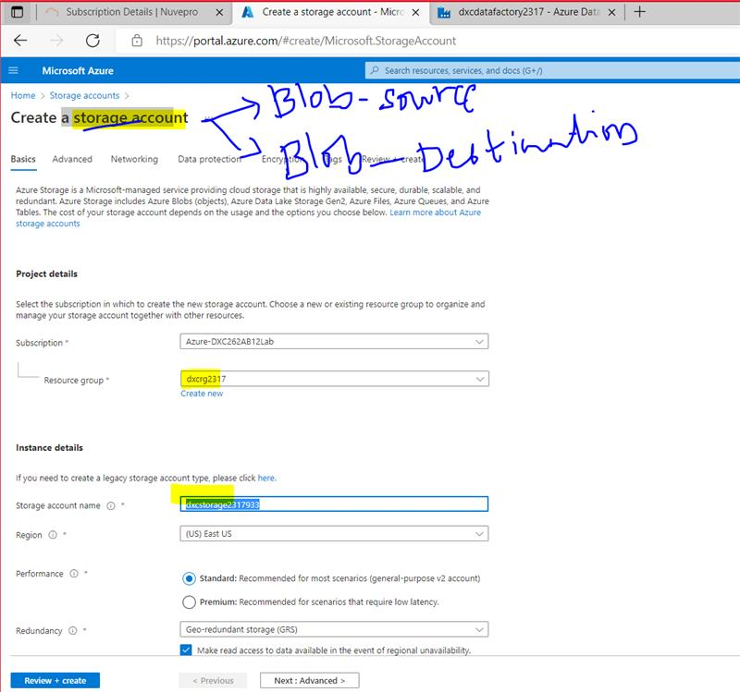

**STEP 2:** After creating ,here we can add the containers in the dxcstorage.

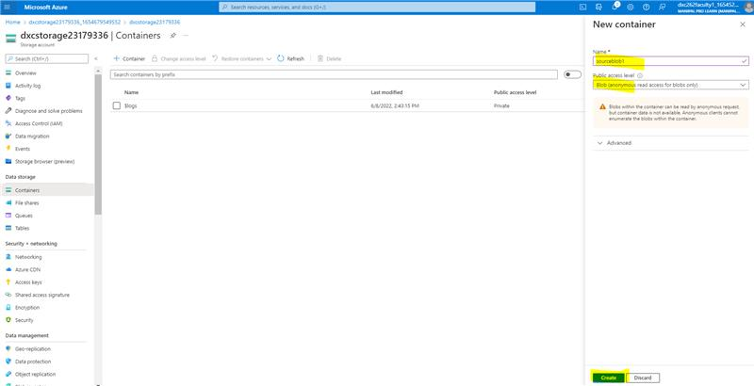

**STEP 3:** As shown the souceblob 1 is added in containers.

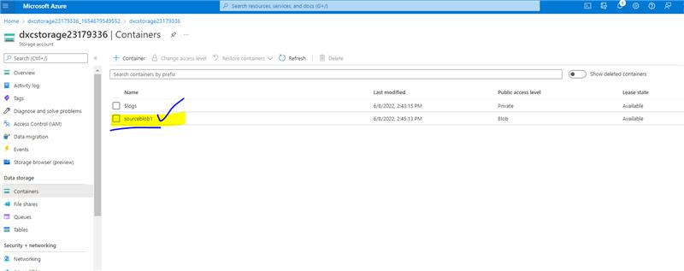

**STEP 4:** And similarly we can add other containers also.

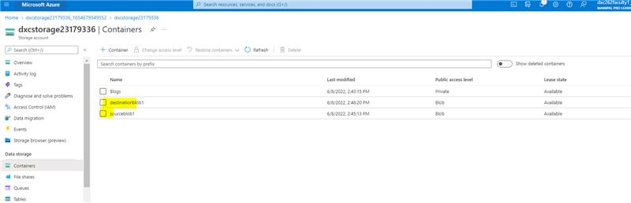

2. Explain the steps with screenshots how to create Virtual machine & how to connect from

(i) Local Computer - CMD method ?

(ii) Using Azure cloud Shell?

(iii) Also using Azure Bastion ?

Solution:

**STEP 1:** In azure portal we have to search for virtual machine and create .

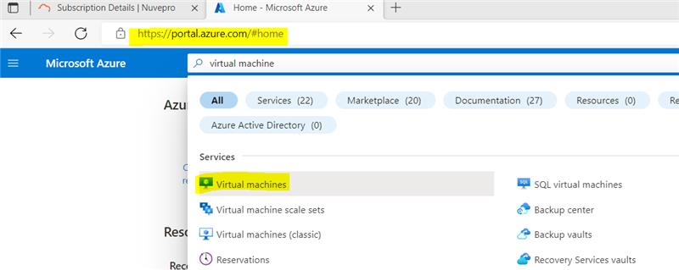

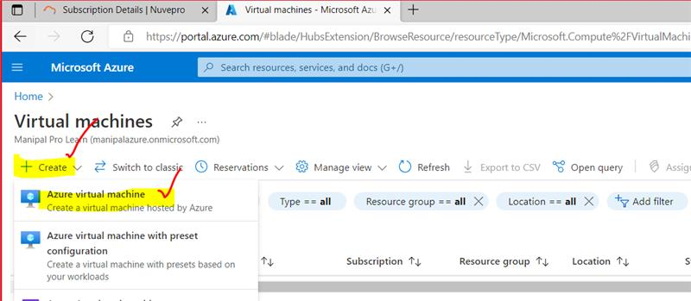

**STEP 2:** After clicking on create ,we have to give the details of resource group and virtual machine name and select the zone.

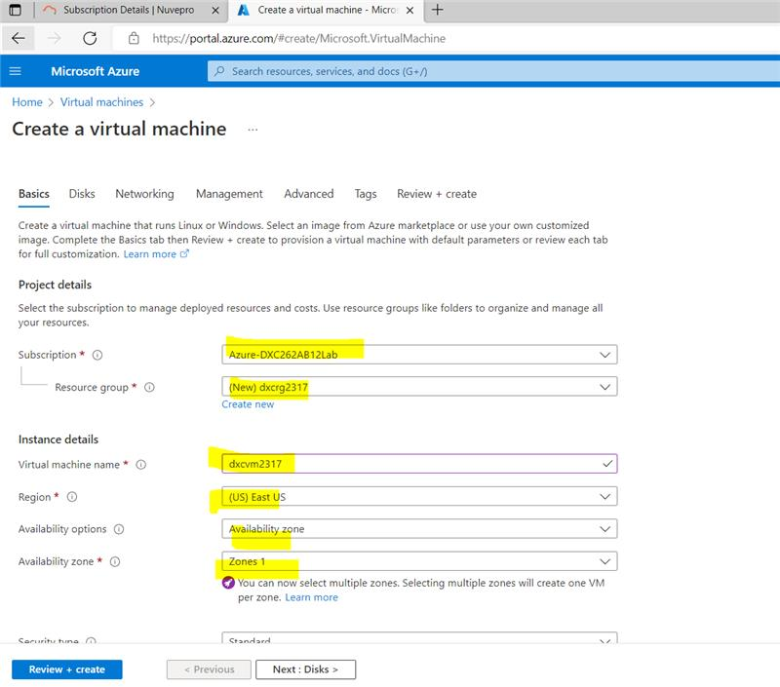

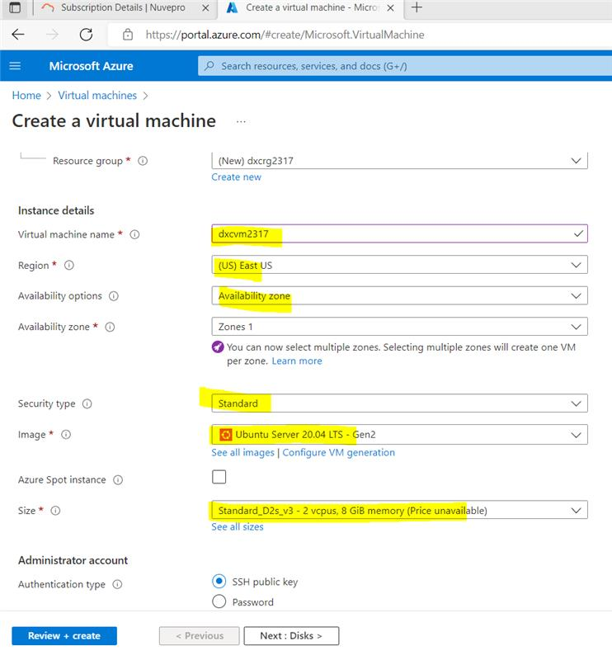

**STEP 3:** After filling the required details we need to create the virtual machine and then download the key shown.

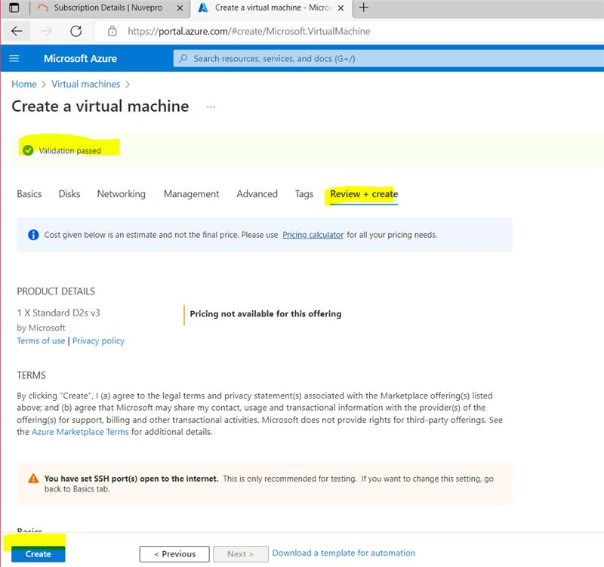

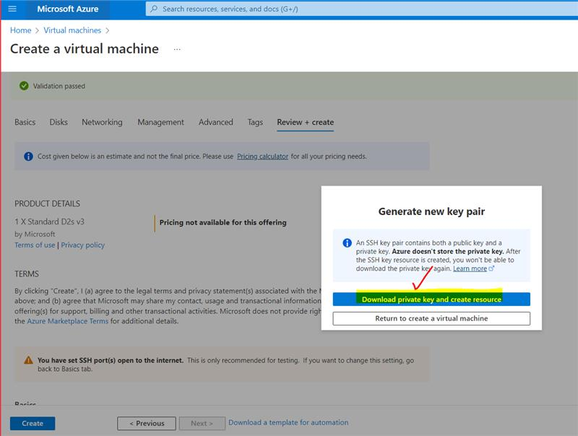

**STEP 4:**  After downloading ,connect SSH and find the key position .

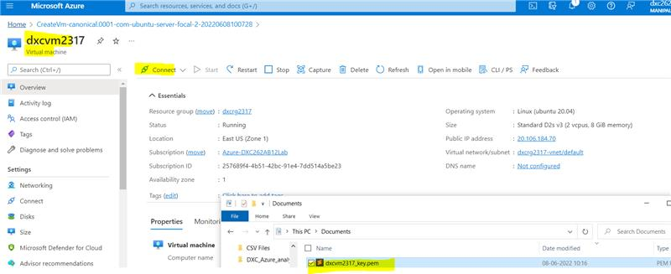

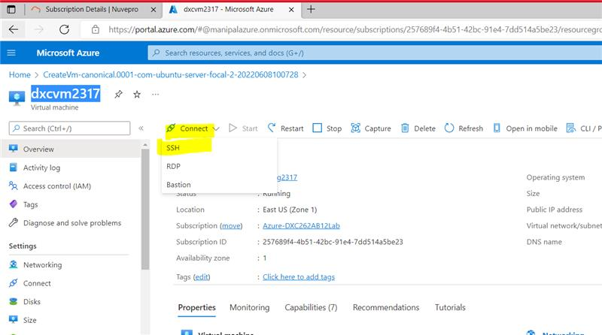

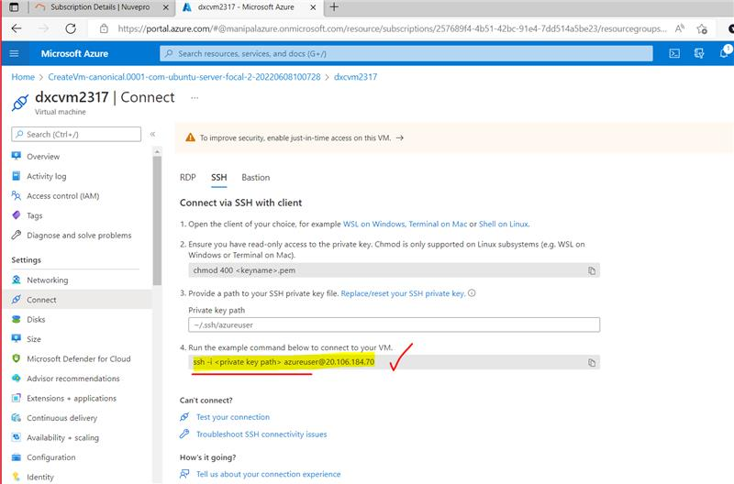

1. **Local Computer - CMD method**

Using command enter the key position and connect the key with SSH.

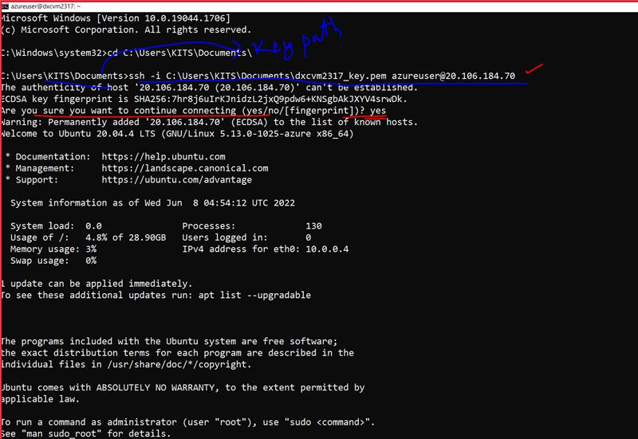

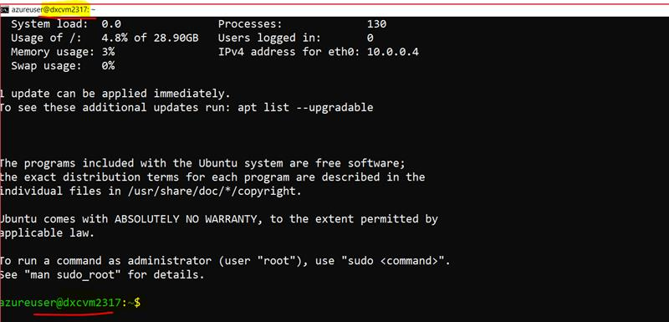

1. **Using Azure cloud Shell**

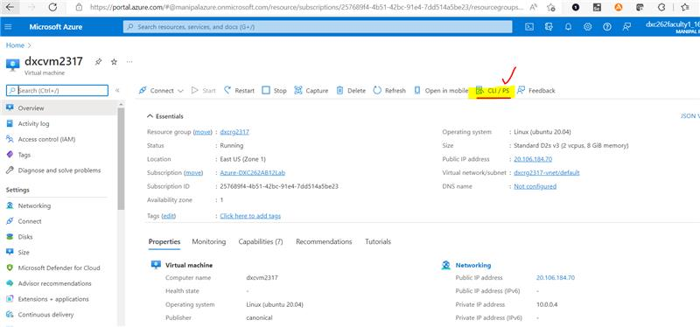

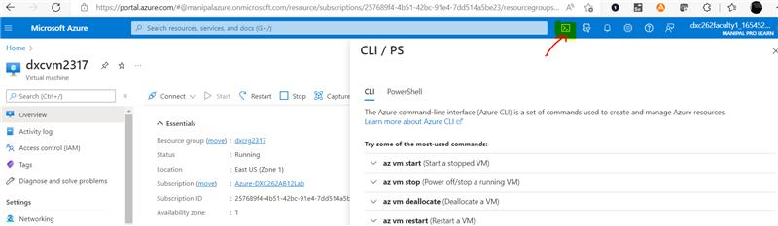

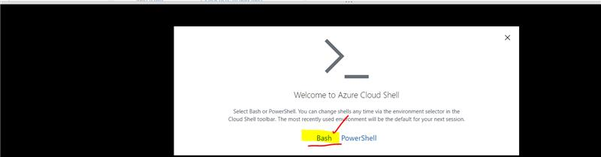

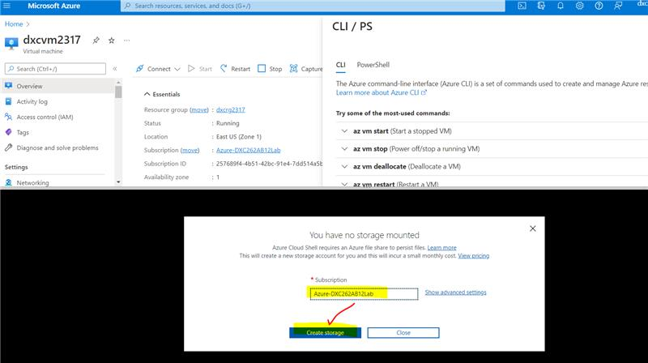

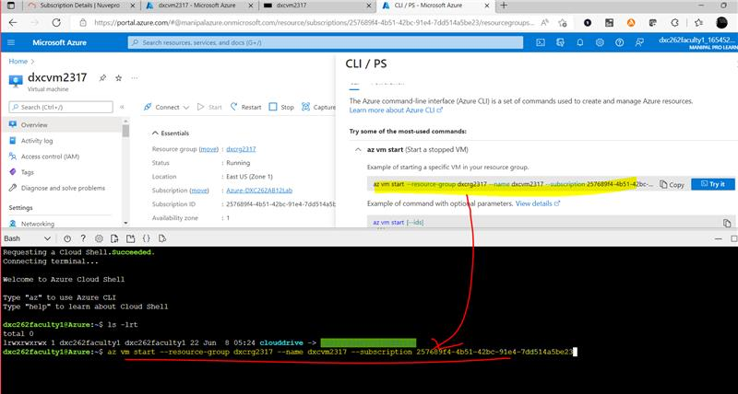

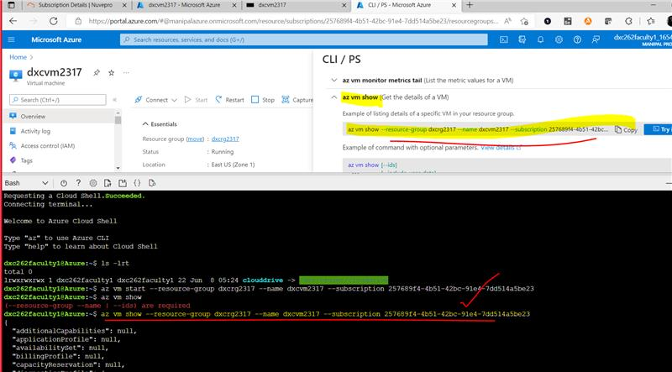

**(iii) Also using Azure Bastion**

In azure bastion, create a new bastion and enter the username and the key and connect.

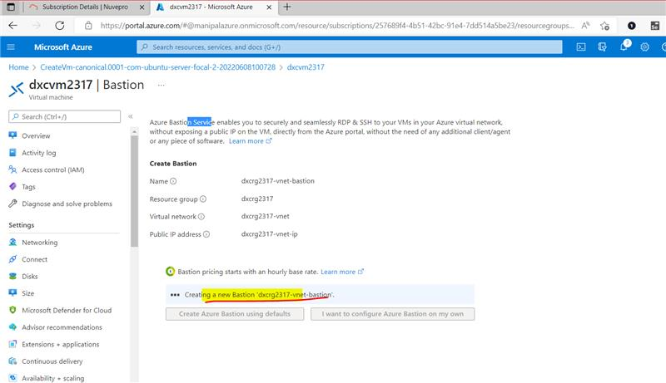

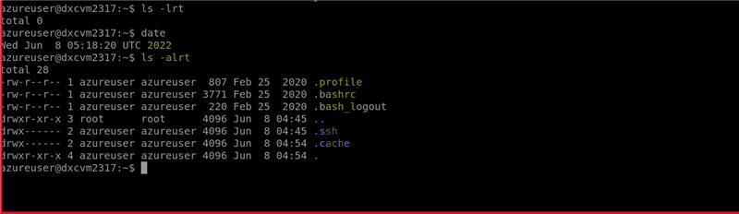

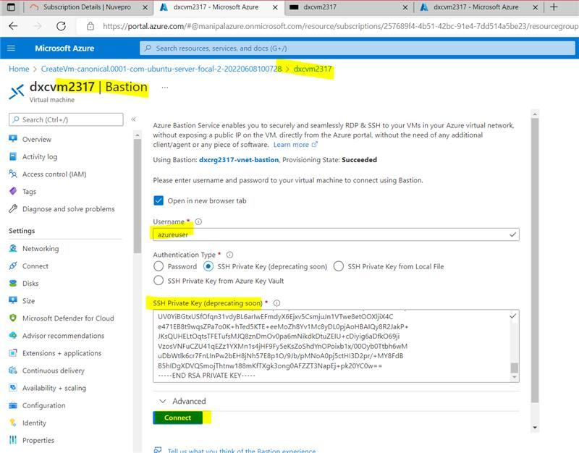

3. Explain the steps with screenshots how to create Data factory ?

Solution:

**STEP 1:** Search data factory and click on create button.

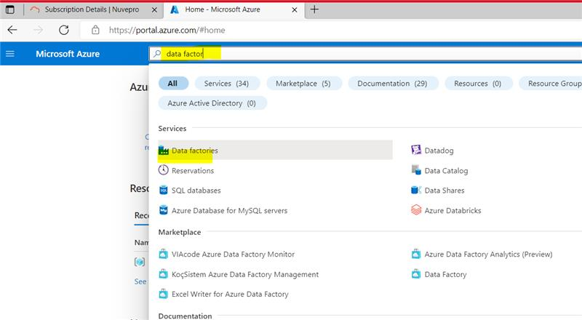

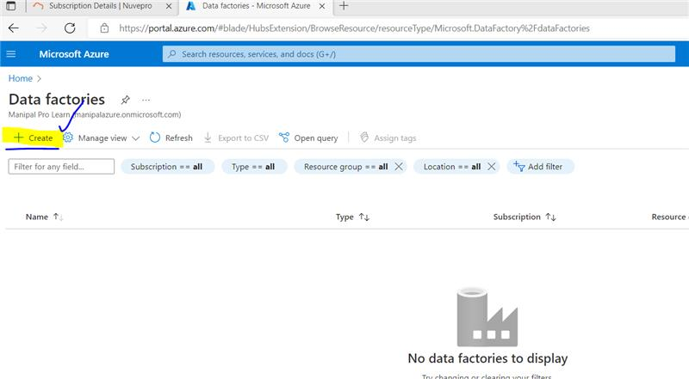

**STEP 2:** And create the data factory by entering the details of resource group,name .

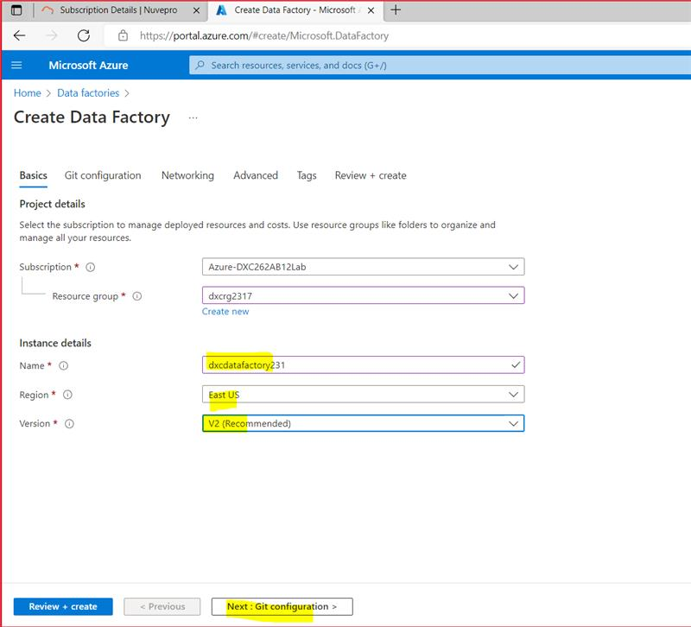

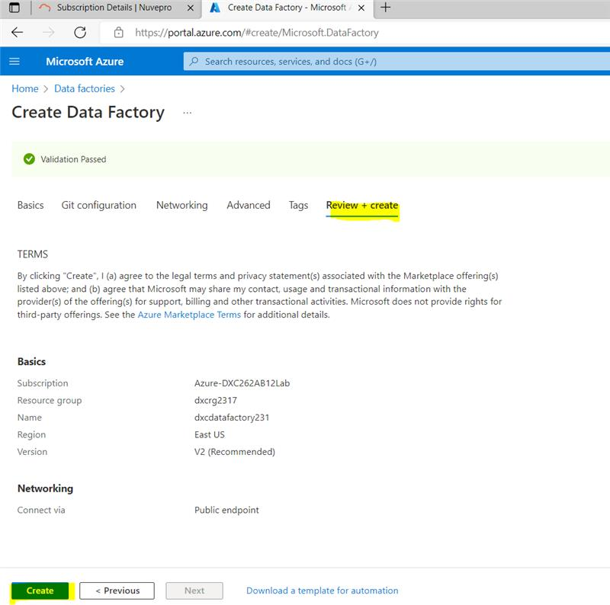

**STEP 4:** After creating deployment will complete and page is opened of daxcdatafactory2317 .

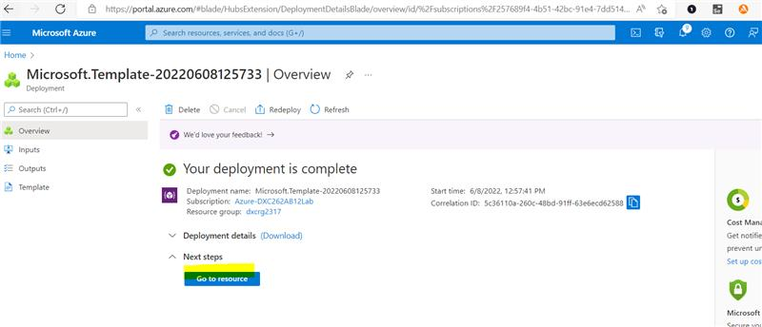

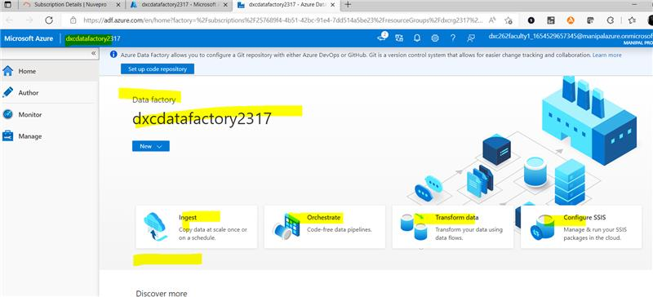

4. Explain the steps with screenshots how to copy data from source blob to destination blob ?

Solution:

**STEP 1:** after opening the datafactory tab we can give input as shown. And then click on built in copy task.

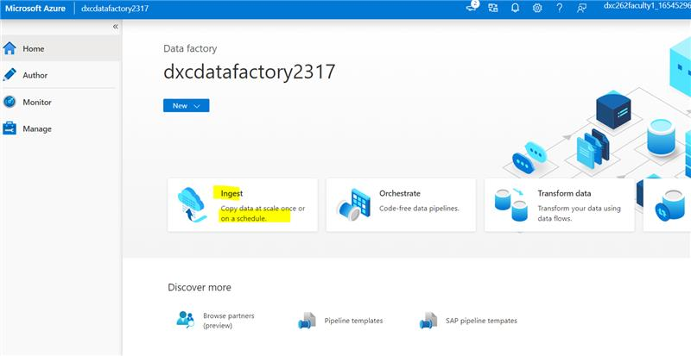

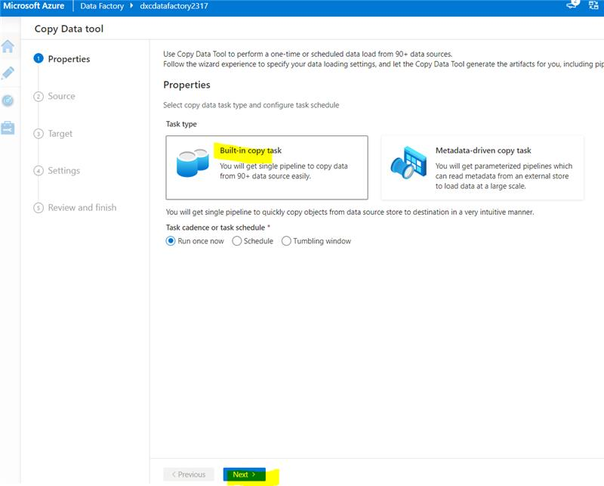

**STEP 2:** enter source type and the connection details.

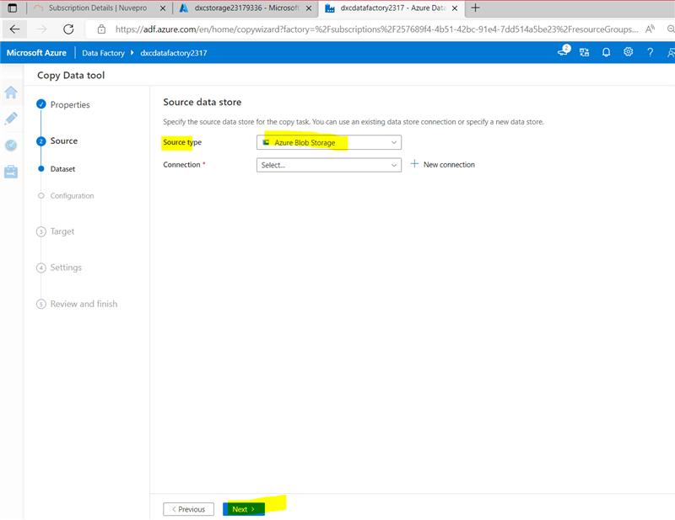

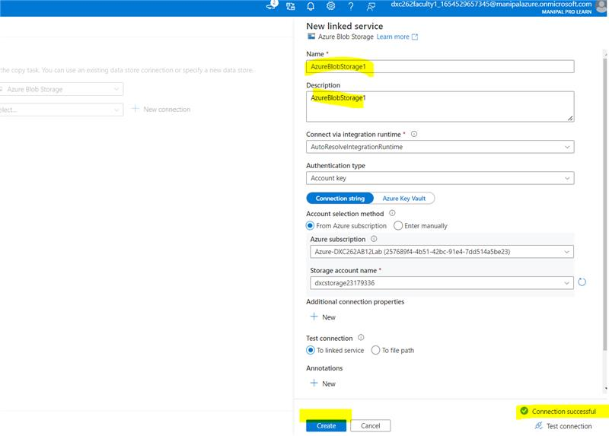

**STEP 3:** in Source data store we have to browse and enter the file that uploaded previously.

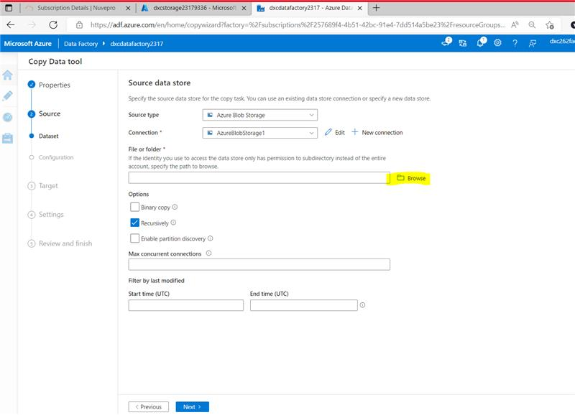

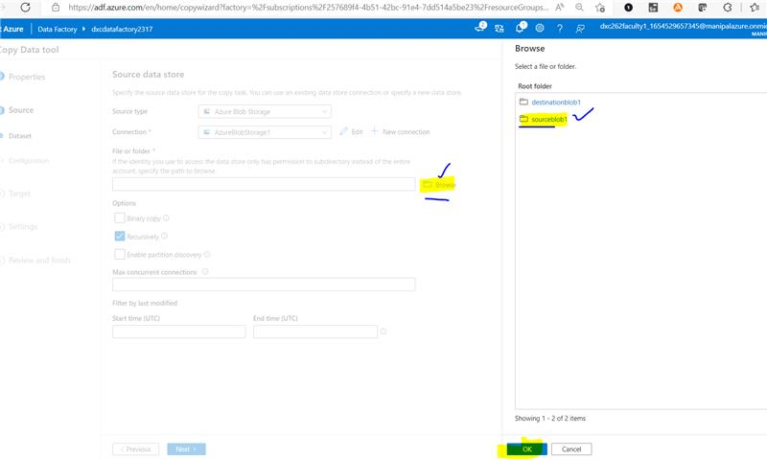

**STEP 4:** In source we have give the details of file format and preview data.

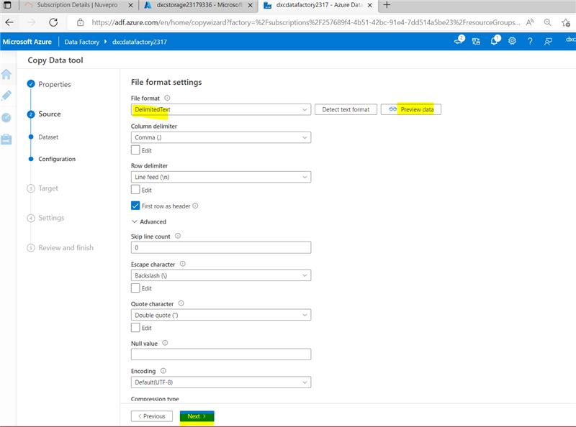

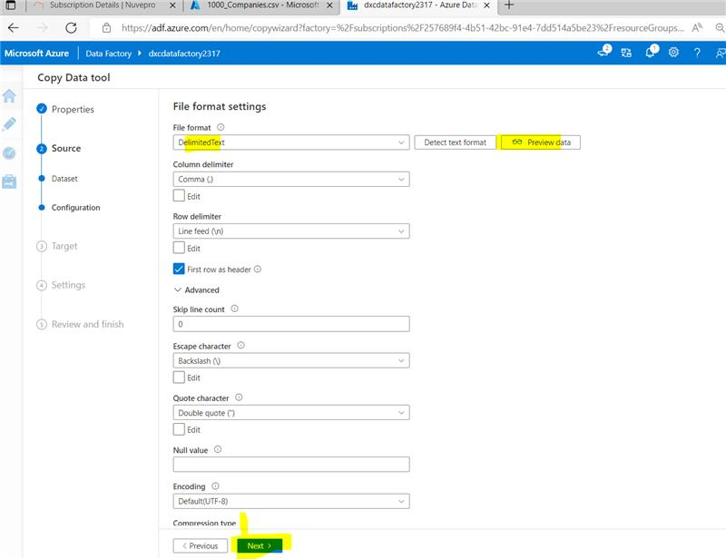

**STEP 5:** In target we need give storage type and folder path by browsing and enter the configure details.

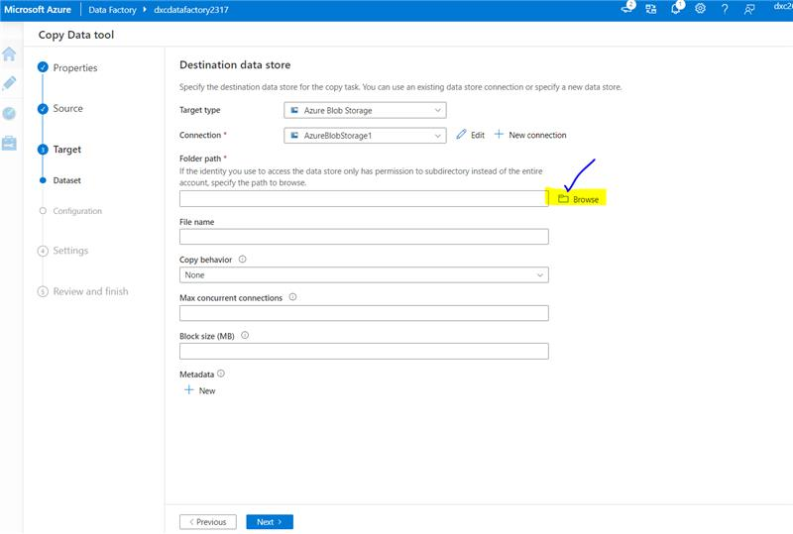

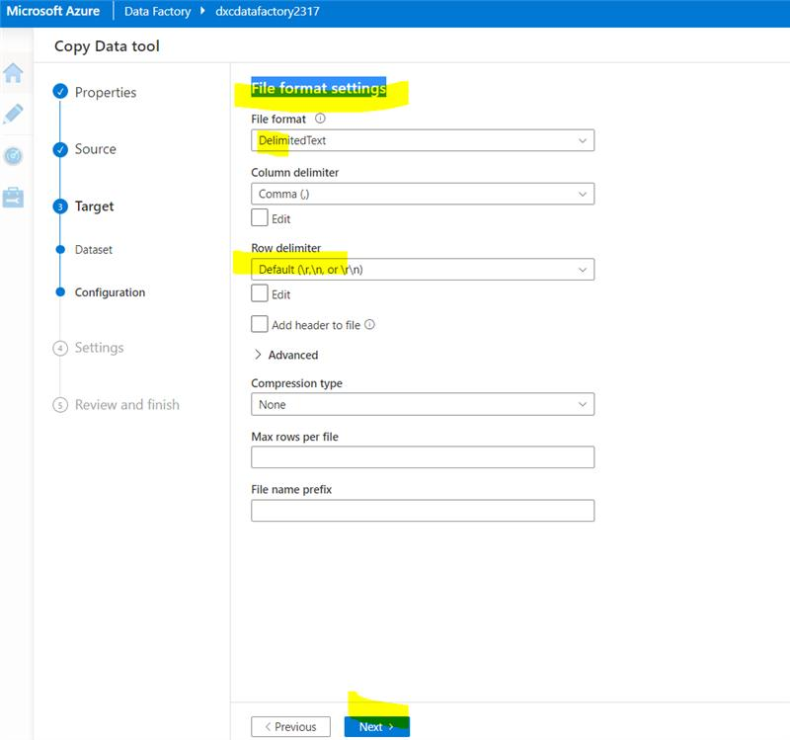

**STEP 6:** The settings and review after that we can finish it.

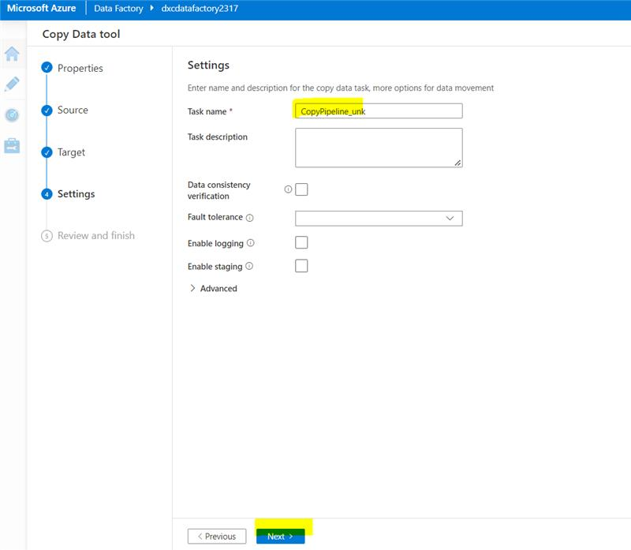

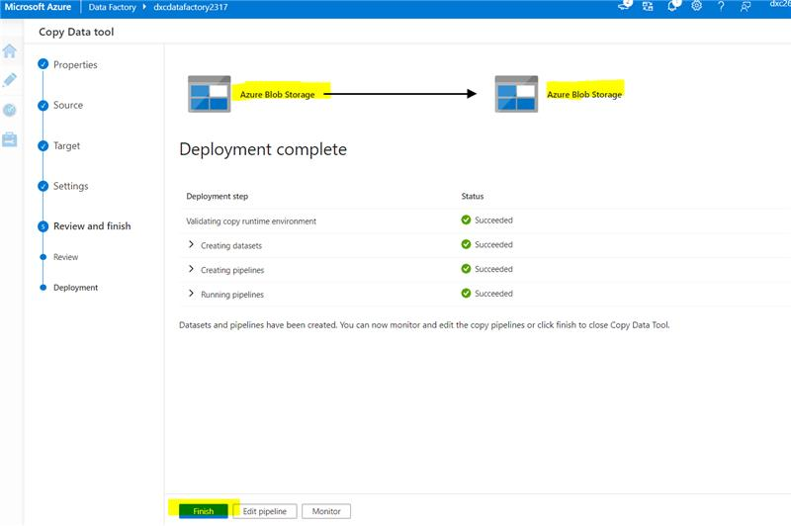

**STEP 7:** After the process of rerun we see the files.

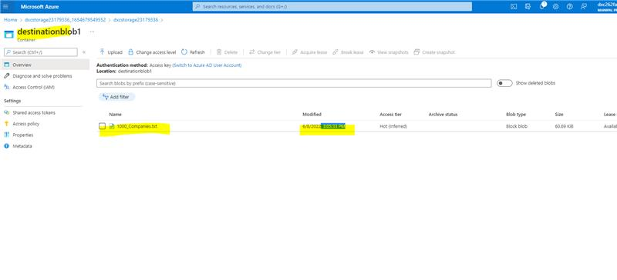

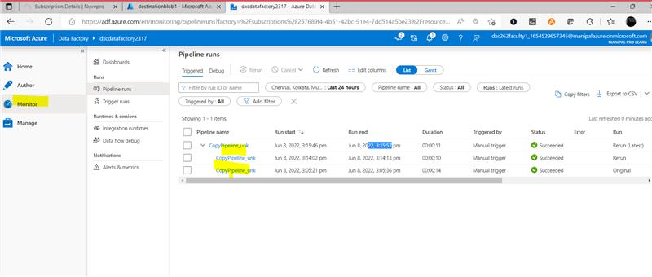

5. Explain the steps with screenshots how to create Virtual Network in Azure ?

Solution:

**STEP 1:** Search virtual networks in azure portal.

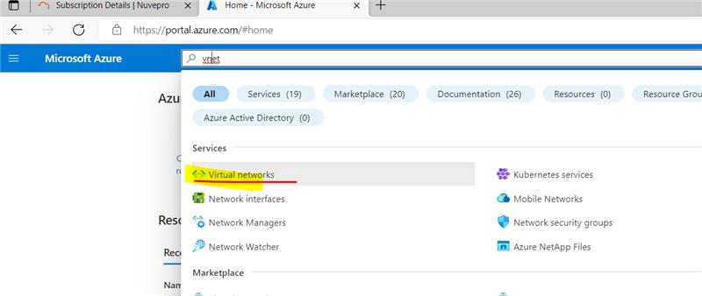

**STEP 2:** click on create button and fill the details of resource group and name and next to IP address.

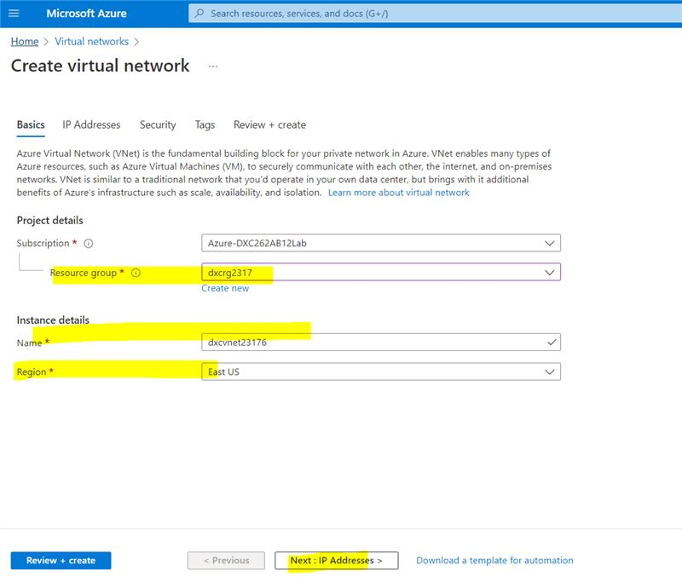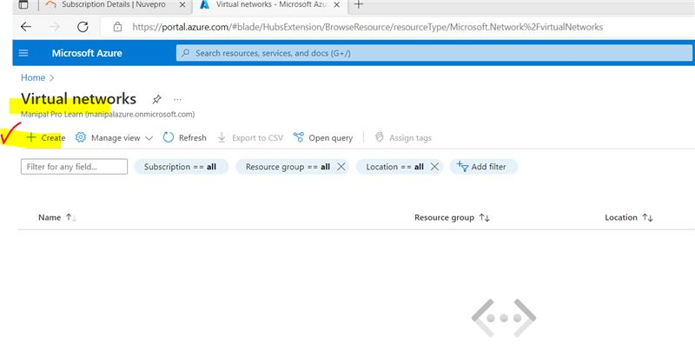

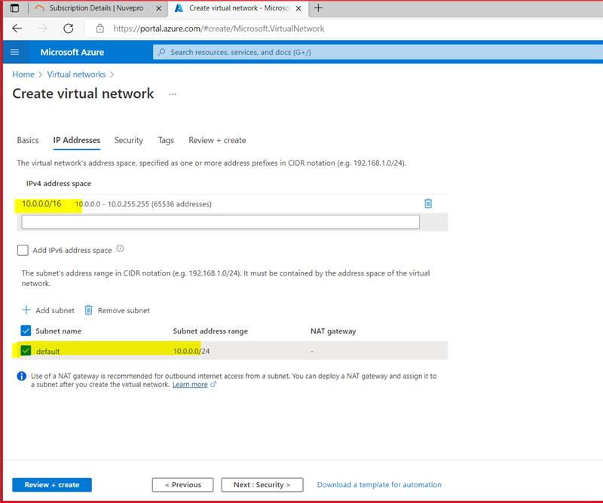

**STEP 3:** Later review and create the virtual network.

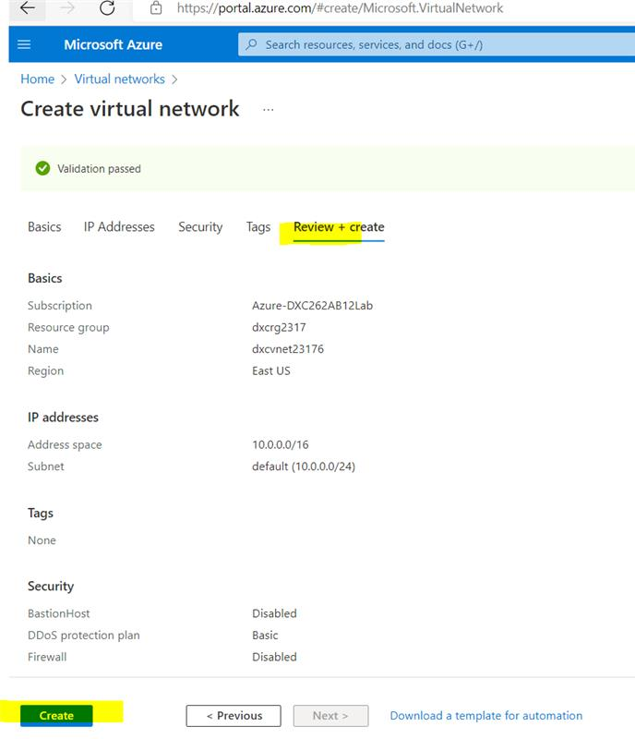

**STEP 4:** After creating the deployment is completed.

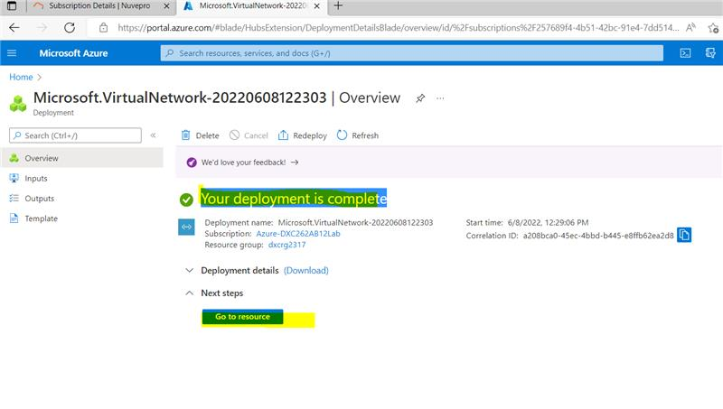

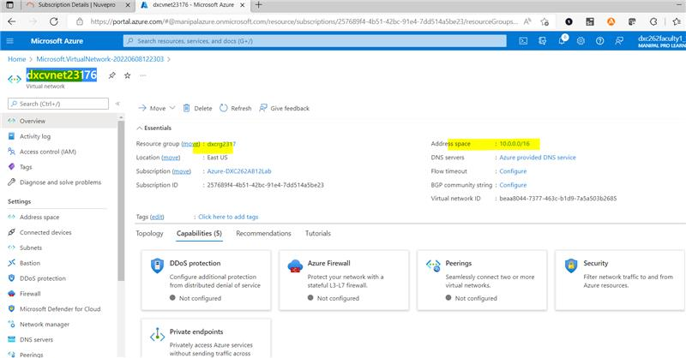

6. Explain the steps with screenshots how to create azure synapse analytics ?

Solution:

**STEP 1:** Search synapse analytics in azure portal. And click on the create button.

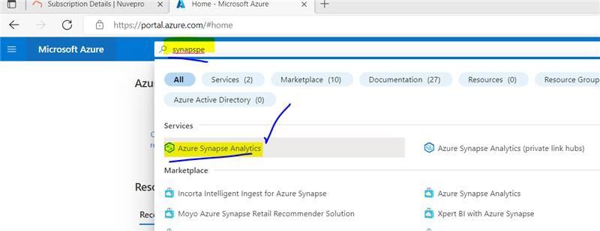

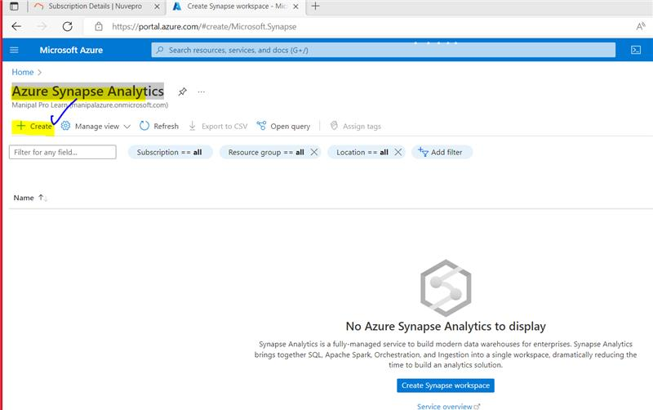

**STEP 2:** For creating we need to enter the resource group and workspace name ,account name ,file system name.

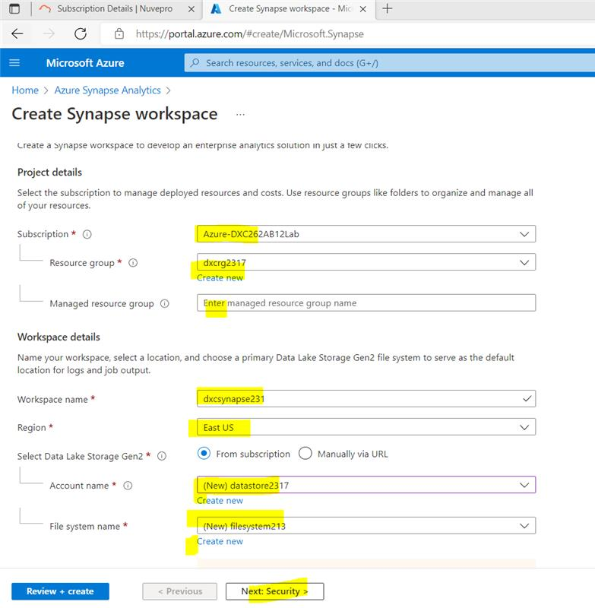

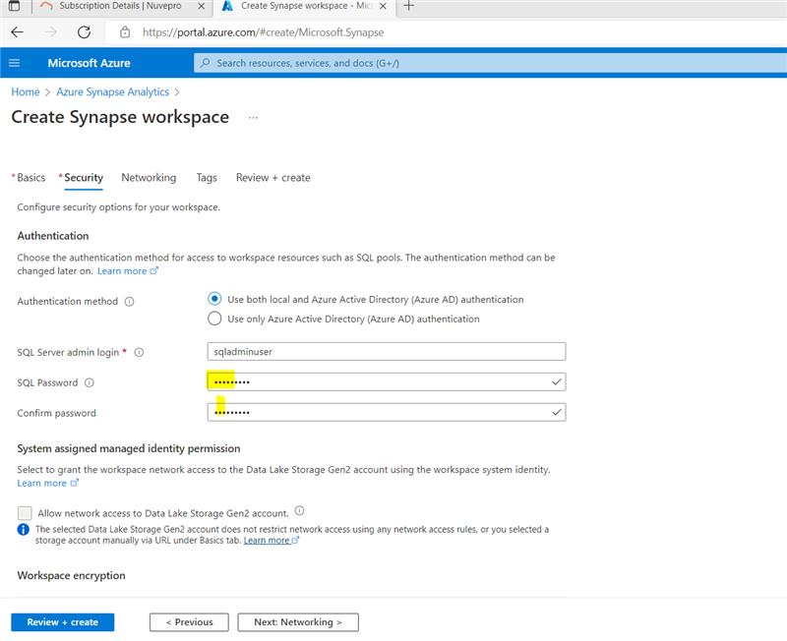

**STEP 3:** After creating the deployment is completed.

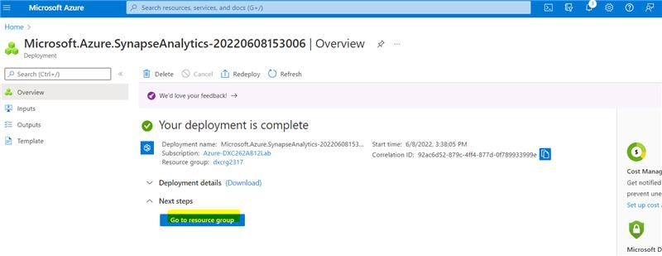

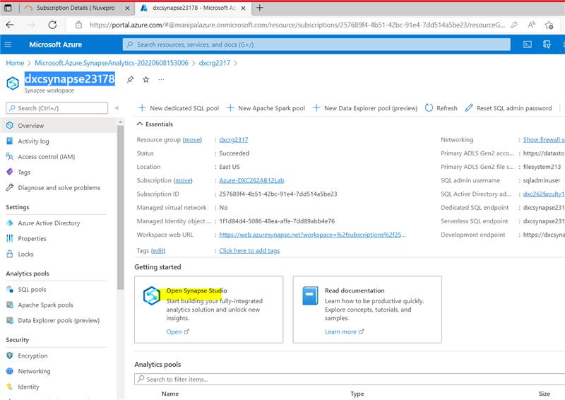

7. Explain the steps with screenshots how to create Azure storage account?

Solution:

**STEP 1:** Search storage accounts and click on create .

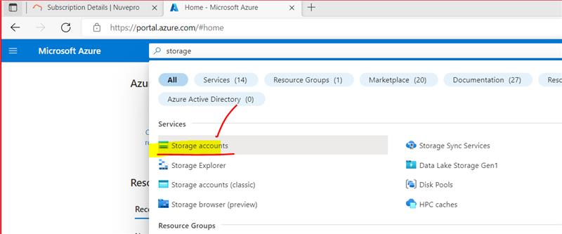

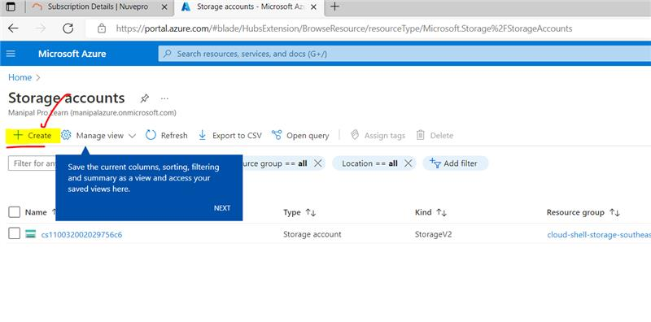

**STEP 2:** For creating we need to enter the resource group and storage account name.

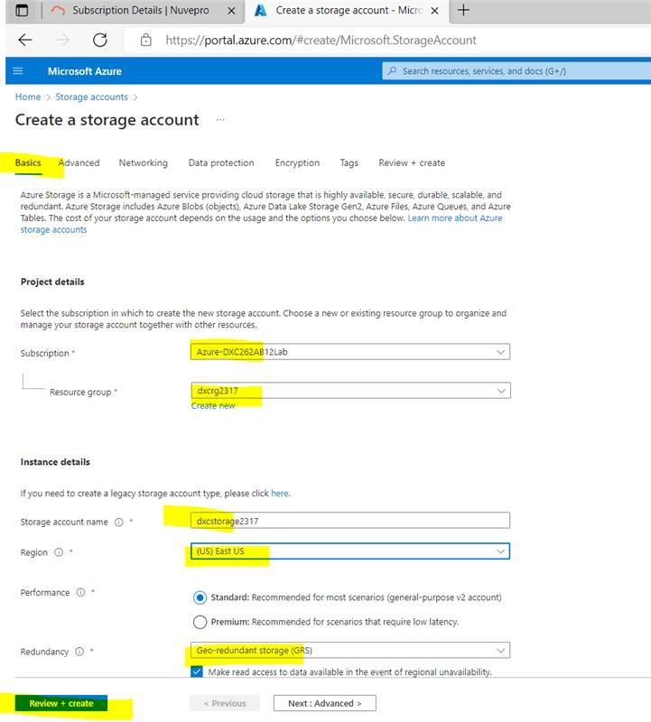

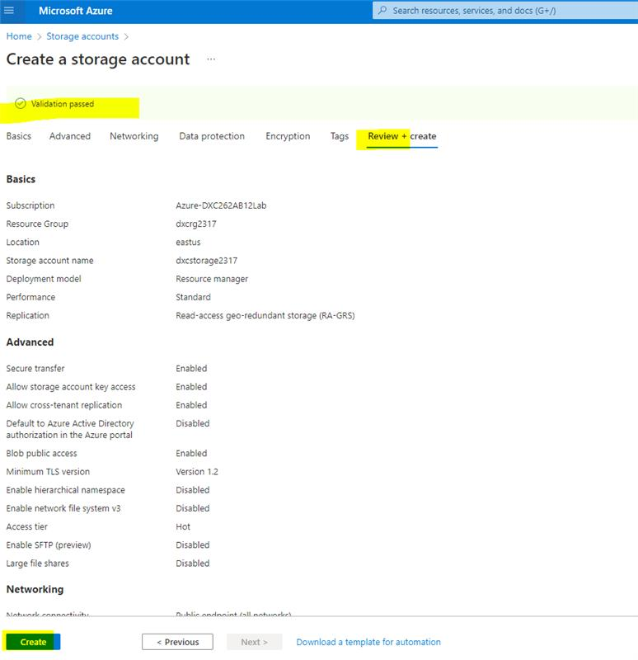

**STEP 3:** After creating the deployment is completed.

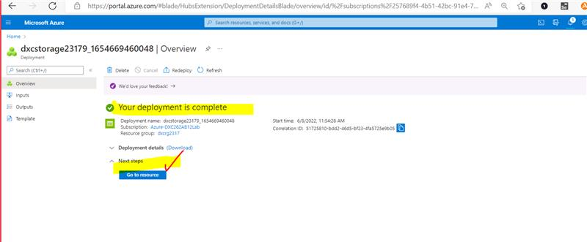

**STEP 4:** Add new containers in it.

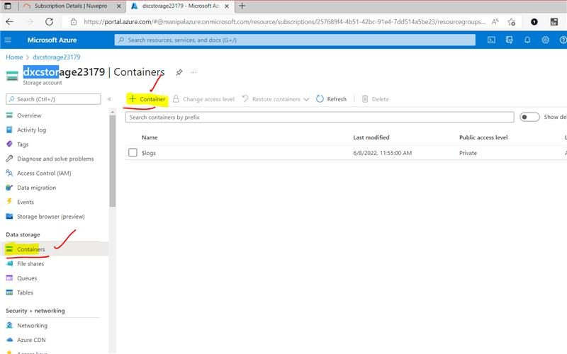

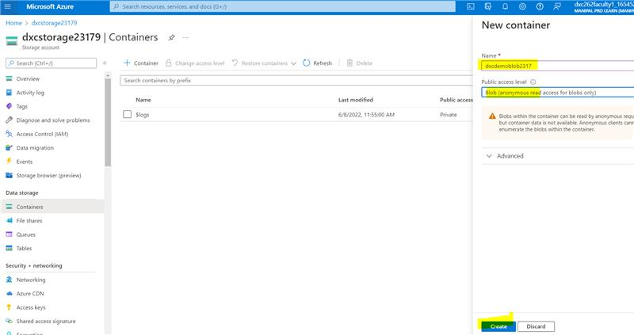

8. Explain the steps with screenshots how to create upload data into Azure Blobs ?

Solution:

**STEP 1:** After creating we can upload any kind file into it and can view it.

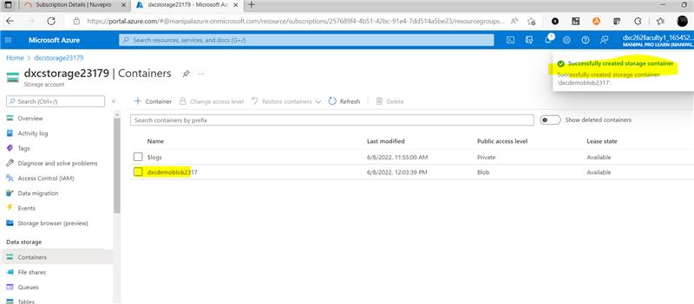

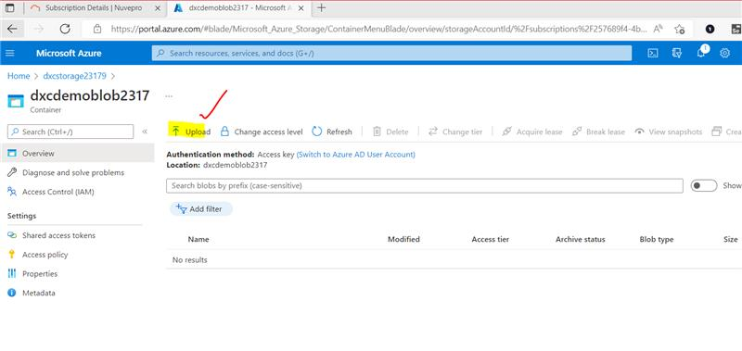

**STEP 2:** And after uploading we can open the file and can edit the details in it.

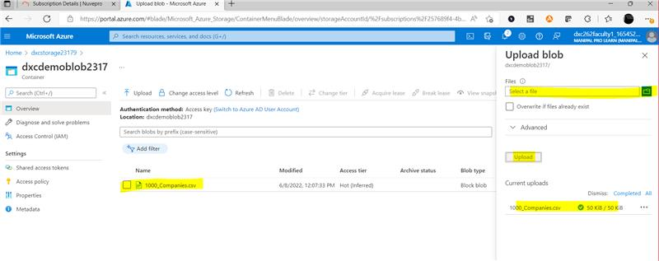

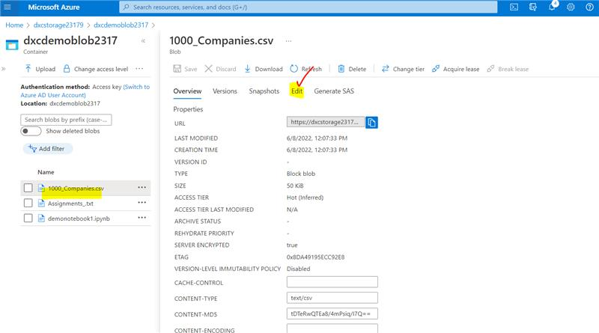

**STEP 3:** open the file and change the values by edit option.

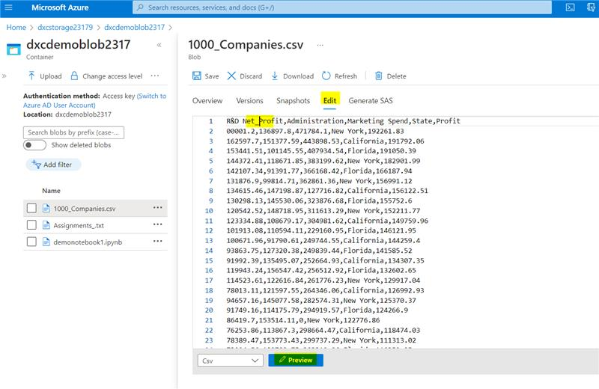

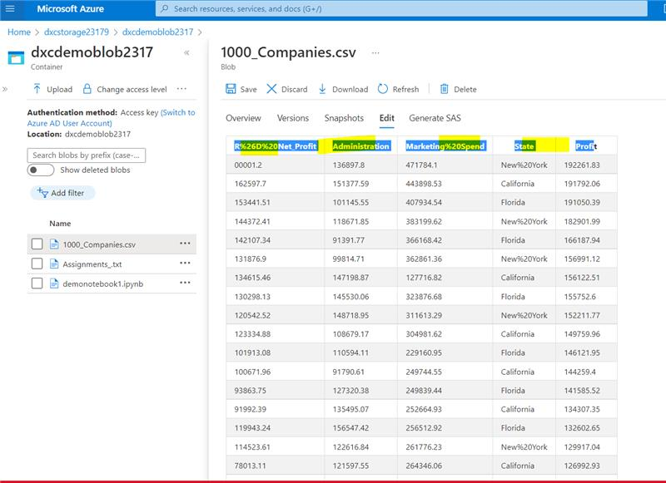

9. Explain the steps with screenshots how to create connect SQL Database in Azure ?

Solution:

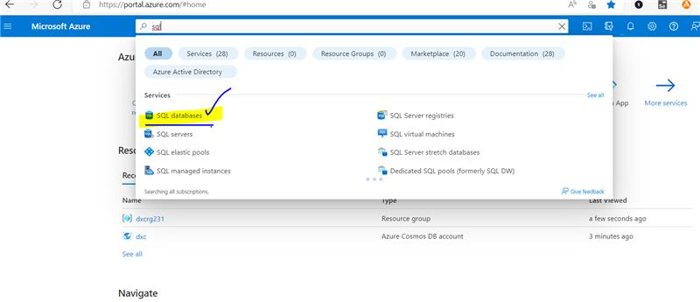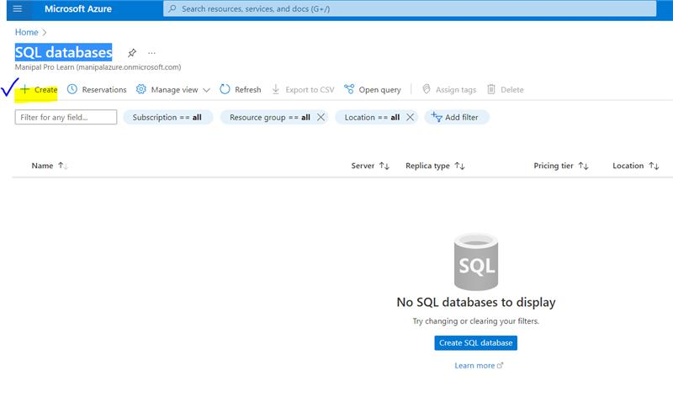**STEP 1:** From the Azure portal menu or the Home page, select Create a resource. On the New page, search for and select SQL Databases.

**STEP 2:** Creating SQL database database id, container id, partition key is given and , for server we have to create SQL Database server by giving the information shown below.

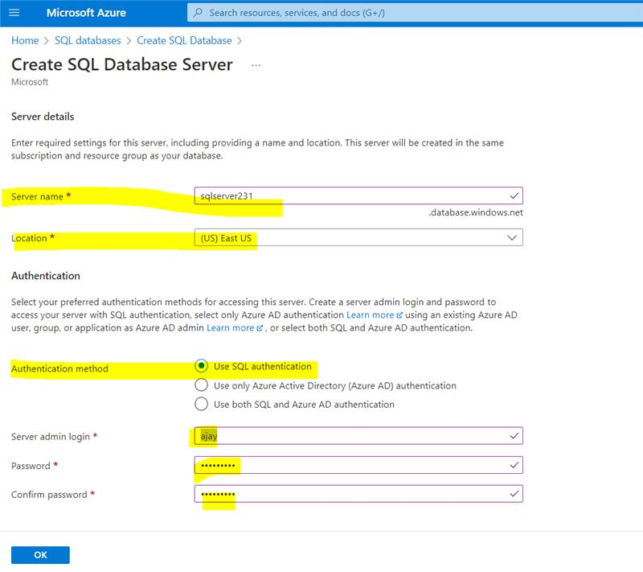

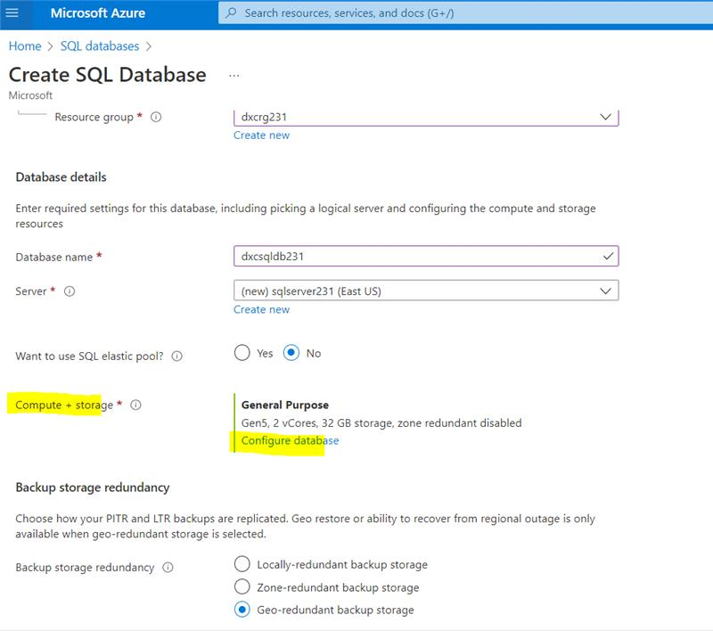

**STEP 3:** For comput + storage the MaxVCores and Data max size should be 1.

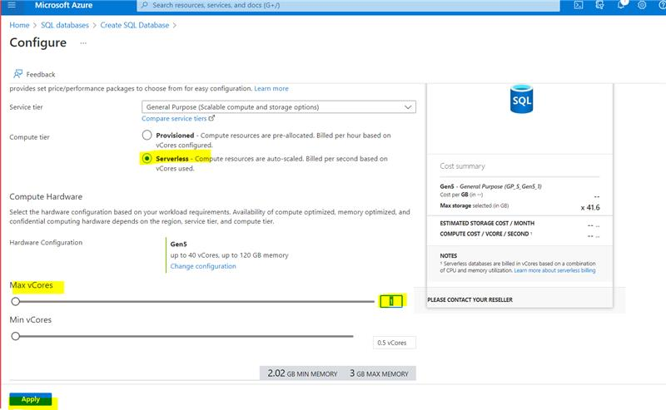

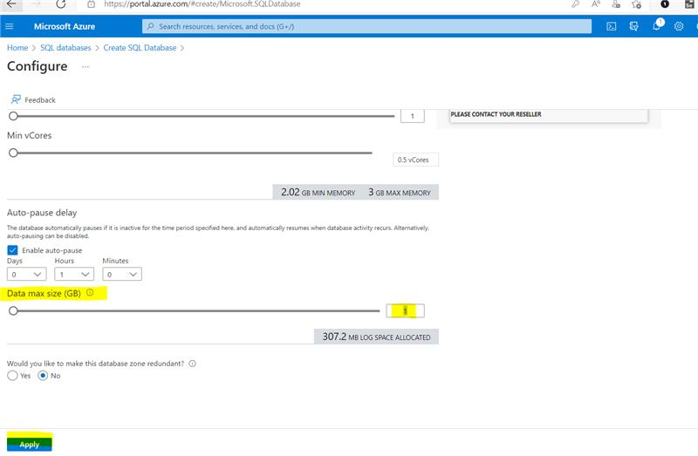

**STEP 4:** Now the SQL database will be created.

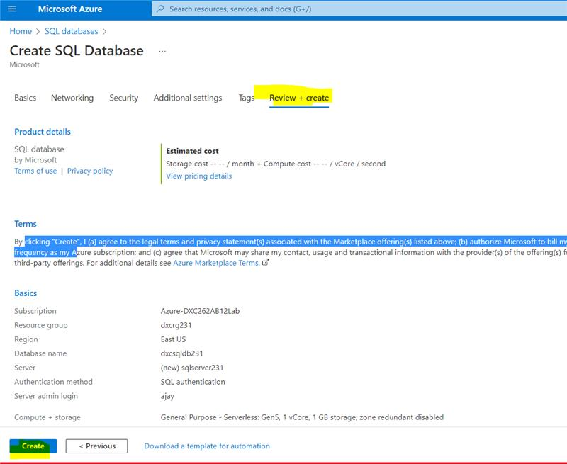

10. Explain the steps with screenshots how to insert data into azure SQL database ?

Solution:

**STEP 1:** For creating the database deployment takes place and for sql the login password should be given as in previous but we need to allow it due to firewall.

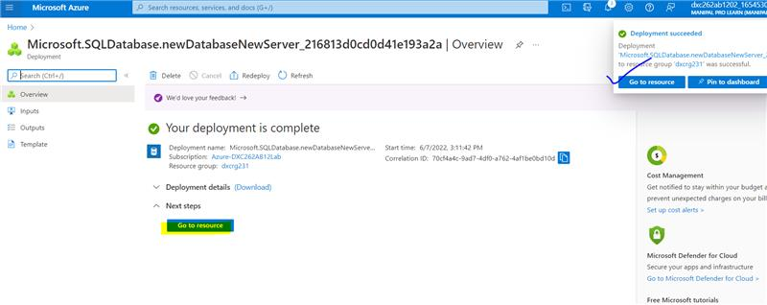

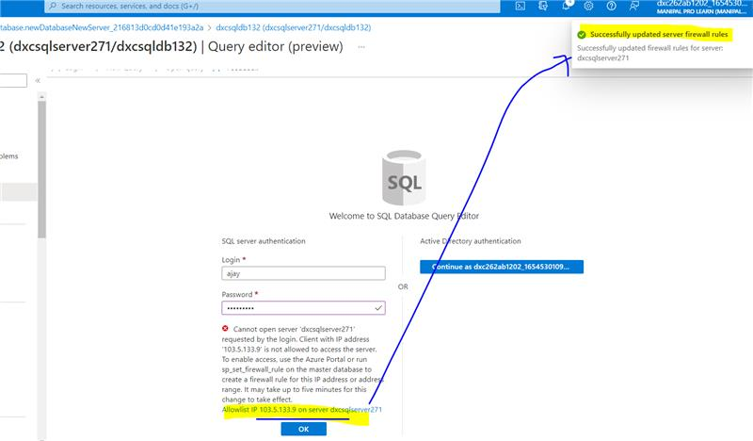

**STEP 2:** Now we need to create table and insert and can view the table by select.

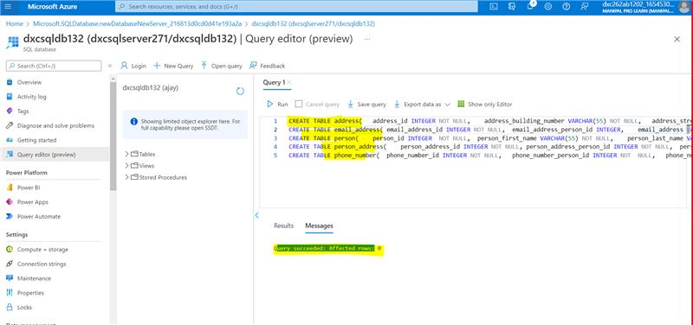

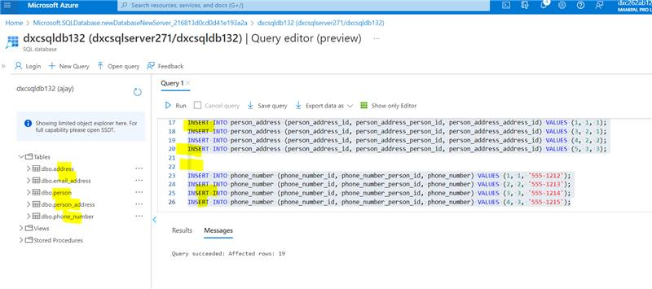

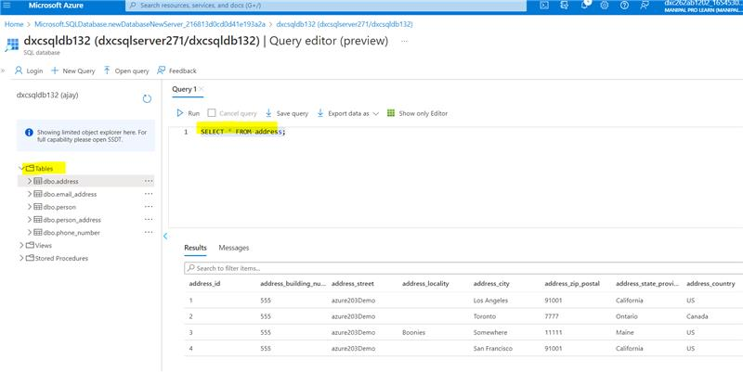

RESULTS:

I HAVE SUCCESSFULLY ANSWERED ALL THE QUESTIONS AS PER ASSIGNMENT REQUIREMENT.

CONCLUSIONS:

All the questions have been solved successfully with all the concepts that have been covered in the training session. It’s really a great experience of learning while solving the cases. This assignment gave me immense confidence regarding my ability to upskill in new technologies.